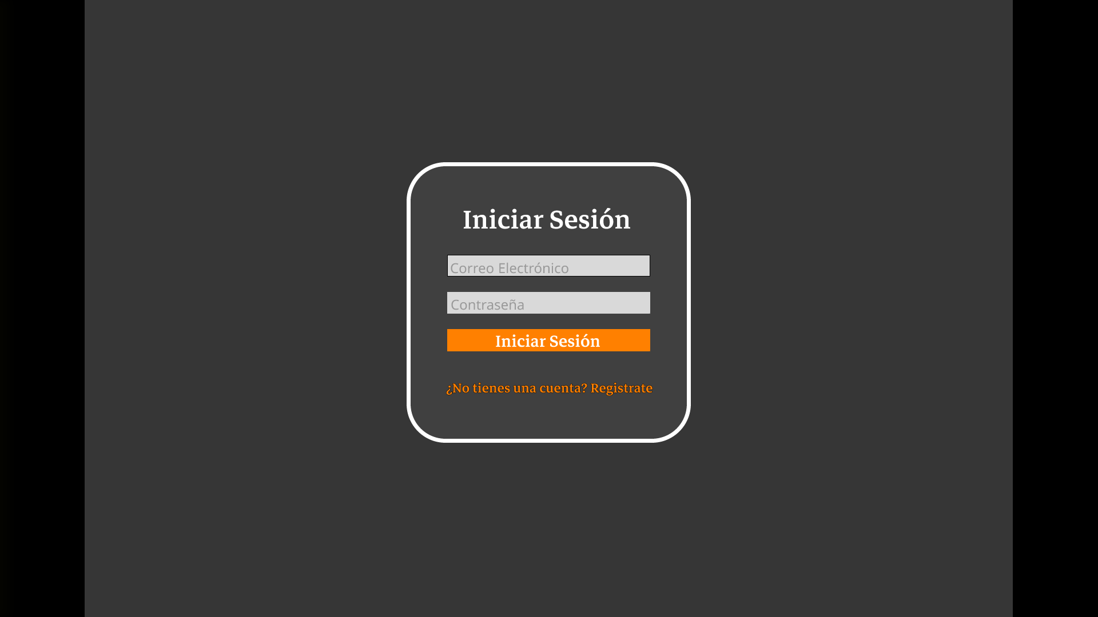

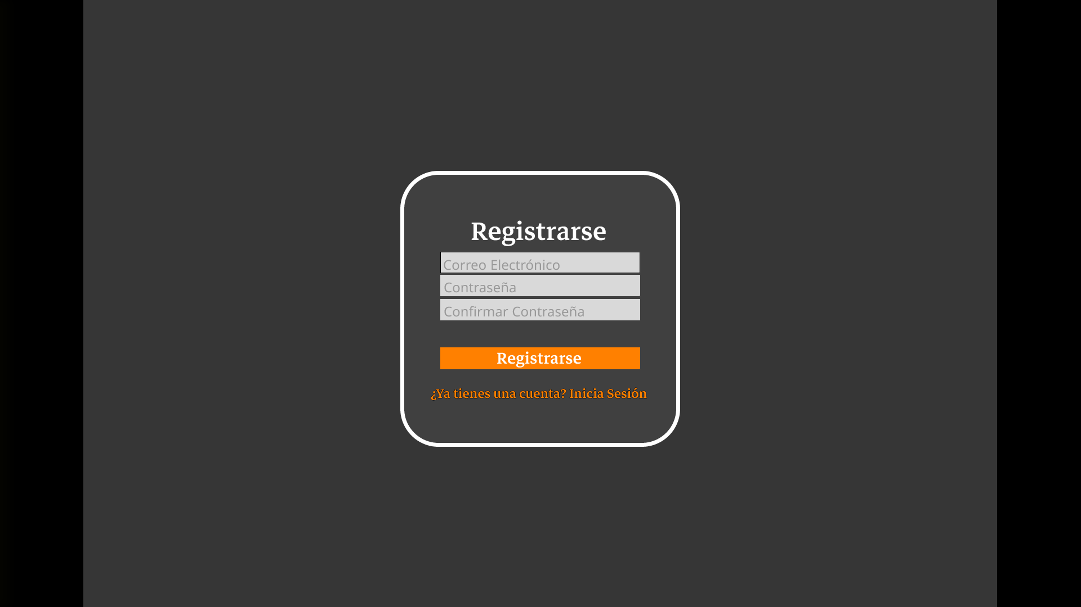

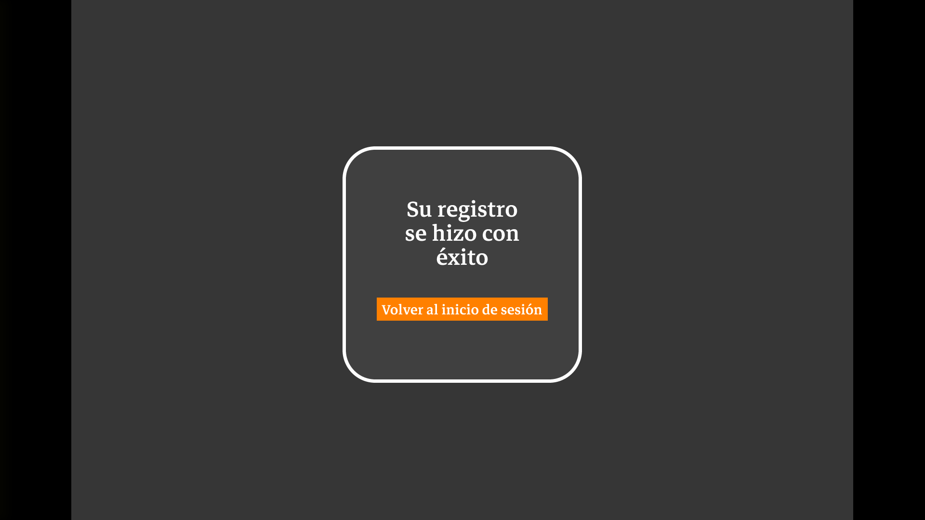



<https://www.figma.com/proto/w2L3ns78yhv47CT2TJ9pT5/Revision?node-id=13-5&t=UoVLkT33GOpz69vs-1&scaling=min-zoom&content-scaling=fixed&page-id=0%3A1&starting-point-node-id=13%3A5>